Neural Tissue
Neural tissue is specialized for receiving, processing, and transmitting signals, allowing the body to respond to changes in its internal and external environment. It is mainly composed of two types of cells: neurons and neuroglial cells.

1. Neurons (Excitable Cells)
The Unit of the System
- Neurons are the structural and functional units of the nervous system.
Excitability
- Neurons are highly excitable cells that are specialized to receive and transmit signals.
Structure
A typical neuron consists of:
- A cell body containing the nucleus
- Branched dendrites, which receive signals from other cells
- A long axon, which carries signals away from the cell body
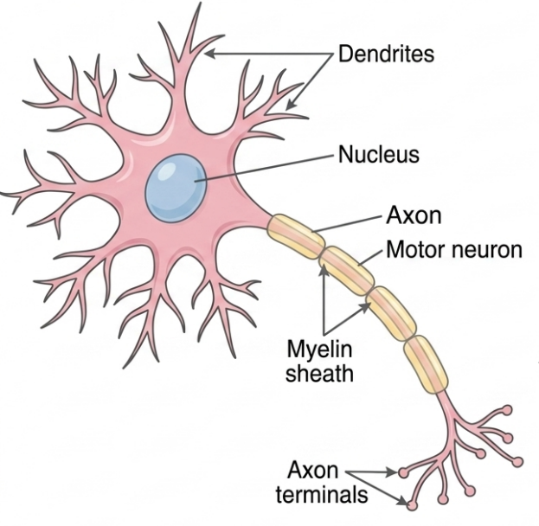

2. Neuroglial Cells (Neuroglia)
Support and Protection
- Neuroglial cells, or neuroglia, support and protect neurons and help maintain the proper environment for their functioning.
Volume
- Neuroglial cells are highly abundant and constitute more than half of the volume of neural tissue.

3. How Neural Signals Work
Generation of Disturbance
- When a neuron receives an appropriate stimulus, an electrical disturbance is generated.
Travel
- The electrical signal travels rapidly along the plasma membrane of the neuron.
Output Zone Events
- When the signal reaches the neuron's endings, or output zone, it triggers chemical or electrical events.
Response
- These events can either stimulate or inhibit adjacent neurons or other cells, such as muscle cells and gland cells.
